About
Westmont College is a private Christian liberal arts college in Santa Barbara, California. It was founded in 1937 as the Bible Missionary Institute. The campus has experienced multiple severe wildfires throughout the 2000s. The college is partially Title IX exempt, meaning they are allowed to discriminate against gay students and other minority groups without losing federal funding.

Prior Conversation
Ellen sent a proposal for $9k in 2021 and lost.

Endowment and Financials
Endowment: $89 million FY23
Revenue: $124 million FY24
Expenses: $117 million FY24
Net Revenue: $6.8 million FY24
Net Assets: $250 million FY24
Source: ProPublica NonProfit Explorer, Institution’s IRS Form 990

2025 Carnegie Classification
Private
Institutional Classification: Special Focus: Arts and Sciences
Highest Degree Awarded: Bachelor’s
Student Access and Earnings Classification: Lower Access, Medium Earnings
Size and Campus Setting: Small, highly residential (1,312 students)
Historical Classification: Baccalaureate Colleges: Arts & Sciences Focus

Lobbying Disclosures
Westmont’s last lobbying disclosure was made in 2017, terminating a contract with Keller McIntyre & Associates. They were registered for $20k per quarter for lobbying for Higher ed and STEM education issues with the Senate, House, and NSF.

Memberships
- American Council on Education (ACE)
- Association of Independent California Colleges and Universities (AICCU)
- Coalition of Christian Colleges and Universities
- Council of Independent Colleges (CIC)
- National Association of Independent Colleges & Universities (NAICU)

Designation
- Emerging Hispanic-Serving Institution (EHSI, 23% Hispanic students)

Key Leaders

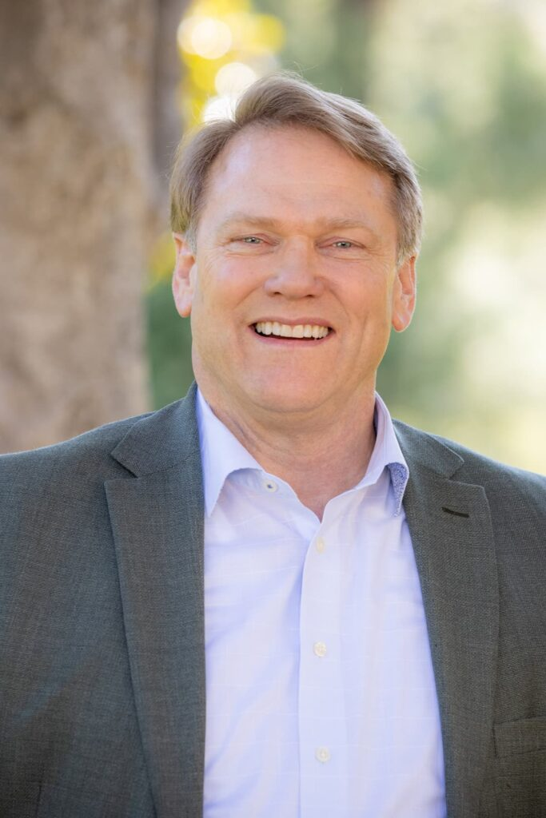
Gayle Beebe, PhD, President
- Prior Experience
  - Westmont College
    - President, 2007-Present
  - Spring Arbor University
    - President, 2000-2007
  - Azusa Pacific University
    - Theology Dean, 1992-2000
- Education
  - Drucker School of Management
    - PhD
    - MBA
  - Princeton Theological Seminary
    - Moral Philosophy MDiv
  - George Fox University
    - Liberal Arts BA
Dr. Gayle D. Beebe has served as the eighth president of Westmont College since 2007.
Under his leadership, Westmont has experienced record fundraising success, exceeding $550 million through multiple comprehensive campaigns. These initiatives have fueled an ambitious campus master plan, adding new facilities for the sciences, visual arts, and athletics while creating the Global Leadership Center, the Martin Institute for Christianity and Culture, and the Dallas Willard Center for Spiritual Formation. His commitment to academic excellence has inspired new programs in engineering, nursing, and leadership studies, along with expanded global and downtown Santa Barbara learning sites that connect students with real-world experience and service.
Dr. Beebe’s tenure has also been defined by steadfast leadership through crisis. He successfully guided Westmont through the 2008 Tea Fire, the 2017 Thomas Fire, the 2018 Montecito debris flow, and the COVID-19 pandemic, earning deep respect for his calm, faith-anchored, and strategic approach to adversity. His capacity to maintain institutional stability while fostering hope and renewal exemplifies the kind of formation he writes about in his most recent book, The Crucibles That Shape Us: Navigating the Defining Challenges of Leadership (InterVarsity Press, 2024).
Before arriving at Westmont, Dr. Beebe served as president of Spring Arbor University in Michigan and as dean of the School of Theology at Azusa Pacific University in Southern California. He holds a B.A. from George Fox University, an M.Div. from Princeton Theological Seminary, an M.A. and Ph.D. in Philosophy of Religion and Theology, and an M.B.A. in Strategic Management from Claremont Graduate University and the Drucker School of Management.
Connect with Dr. Beebe on LinkedIn

Foundation Funding
Foundation Funding Total 2018-2025: $45,857,460 (174 awards)
Link to Foundation Funding History
Between 2018 and 2025, Westmont College received an impressive $45.8 million in philanthropic support, with gifts concentrated on undergraduate education, scholarships, capital projects, and specialized programs. The largest contributions came from donor-advised funds, particularly National Christian Charitable Foundation and Donor Advised Charitable Giving, Inc., which together account for tens of millions in unrestricted educational support. Major programmatic investments were made by Lilly Endowment Inc., funding leadership and ministry initiatives, and John Templeton Foundation, supporting research and character development projects. Significant capital and infrastructure gifts came from The Ahmanson Foundation, Hugh & Hazel Darling Foundation, and Fletcher Jones Foundation, while recurring scholarship support was provided by Brightstar Foundation and others. Additional notable donors include Tom and Meg Names Family Foundation, Gs Donor Advised Philanthropy Fund, and regional foundations such as Santa Barbara Foundation, reflecting a strong mix of national and local philanthropic engagement.
Top 10 donors by approximate cumulative giving (2018–2025):
- National Christian Charitable Foundation, Inc. — ~$8.4M
- Gs Donor Advised Philanthropy Fund for Wealth Management Inc. — ~$7.7M
- Donor Advised Charitable Giving, Inc. — ~$5.6M
- Lilly Endowment Inc. — ~$4.2M
- The Ahmanson Foundation — ~$1.7M
- Tom and Meg Names Family Foundation — ~$1.4M
- The Valley Rock Foundation — ~$1.2M
- Hugh & Hazel Darling Foundation — ~$1.3M
- Fletcher Jones Foundation — ~$1.2M
- John Templeton Foundation — ~$0.8M

Federal Funding
Agency, Office: Program |  | Start Date | Total Funding | Description
NSF, Integrative Organismal Systems: Ecological Physiology | 2023 |  | $681,543 | Collaborative Research: How to get SMAL: Studying island dwarfism to find Shared Molecular mechanisms Across Life history traits  Amanda Sparkman (Principal Investigator) sparkman@westmont.edu  This project will contrast mainland California and California Channel Island populations of five reptile species to understand the changes in their genomes, cells, and hormone physiology that alter their body size and reproduction on the islands. This project will engage over 30 undergraduate and graduate students (across three universities) and high school teachers in the research and will support the development of teaching modules based on scientific research.
NSF, Physics: High Energy Physics | 2022 |  | $200,000 | RUI: Casting Light On A Semi-Visible Higgs Boson With Novel Triggers At ATLAS  Benjamin Carlson (Principal Investigator) bcarlson@westmont.edu  This award will provide support for work on the ATLAS experiment at the Large Hadron Collider (LHC) at CERN, a particle physics laboratory in Geneva, Switzerland.  This award will develop tools for detecting new Beyond Standard Model physics by improving the trigger selection using machine learning (ML) techniques. This RUI will allow students to directly take part in the analysis of the LHC data and learn new ML techniques. They will also develop outreach programs with local high schools.
NSF, Chemical, Bioengineering, Environmental, and Transport Systems: Disability & Rehab Engineering | 2019 |  | $186,276 | Unraveling posture control in severe cerebral palsy.  Adam Goodworth (Principal Investigator) agoodworth@westmont.edu  This project will focus on understanding the complex task of trunk posture control in children with severe CP. Educational activities associated with this project will engage students with and without CP who are in high school, undergraduate, and graduate school. In addition to learning about posture control, students will learn about modeling and control systems. Finally, students will be engaged in creating and testing a unique dissemination tool.

Congressionally Directed Funding
Sen. Alex Padilla (D-CA) and Sen. Adam Schiff (D-CA) represent Westmont. Both participate in the earmarks process. Neither have secured an earmark for Westmont.
Rep. Salud Carbajal (D-CA-24) represents Westmont. He participates in the earmarks process but has not secured an earmark for Westmont.

HERD Ranking and Research Expenditures
Not HERD ranked

Grants Office
Westmont does not have a grants office.

Recent News
First Theological Leadership Cohort Marks Graduation
Dec 16, 2025
Westmont’s inaugural cohort of theological leadership students celebrated their graduation during a special dinner Dec. 4 in Hieronymus Lounge. This was the final event for the eight students who each shared a personal story about the impact of the program before they received their certificate in theological leadership.
President Gayle D. Beebe, who taught several of the theological leadership courses, spoke about the importance of theological education and summarized the concepts the students had learned, including human nature, the human condition, ultimate reality and sin. He referencing thinkers like Pascal and Augustine to emphasize the Christian view that humans are both great and wretched, with Jesus Christ as the remedy.

